A Project Report

*On*

VEHICLE TRADING MANAGEMENT SYSTEM

*By*

YASH SRIVSTAVA (Roll No.307A063)

ARSH SRIVASTAVA (Roll No.307A060)

*Under the guidance of*

Prof. Mr K.B. SADAFALE



**Department of Information Technology**

**Sinhgad College of Engineering**

**SAVITRIBAI PHULE PUNE UNIVERSITY**

**2020-2021**

|  |  |
| --- | --- |
| Sinhgad Technical Education Society,  Department of Information Technology  Sinhgad College of Engineering, Pune-41 |  |

Date:

**CERTIFICATE**

This is to certify that,

YASH SRIVSTAVA (Roll No.307A063)

ARSH SRIVASTAVA (Roll No.307A060)

of class T.E IT; have successfully completed their project work on “VEHICLE TRADING MANAGEMENT SYSTEM’’ at SINHGAD COLLEGE OF ENGINEERING in the partial fulfillment of the Graduate Degree course in T.E at the Department of Information Technology, in the academic Year 2020-2021 Semester – I as prescribed by the Savitribai Phule Pune University.

Prof. K. B. Sadafale Prof. G. R. Pathak

Guide Head of the Department

(Department of Information Technology)

**Acknowledgement**

I feel great pleasure in expressing my deepest sense of gratitude and sincere thanks to my guide **Prof. K.B. Sadafale** for their valuable guidance during the Project work, without which it would have been very difficult task. I have no words to express my sincere thanks for valuable guidance, extreme assistance and cooperation extended to all the **Staff Members** of my Department.

This acknowledgement would be incomplete without expressing my special thanks to **Prof.G. R. Pathak** Head of the Department (Information Technology) for their support during the work.

I would also like to extend my heartfelt gratitude to my **Principal, Dr. S. D. Lokhande** who provided a lot of valuable support, mostly being behind the veils of college bureaucracy.

Last but not least I would like to thank all the Teaching, Non- Teaching staff members of my Department, my parent and my colleagues those who helped me directly or indirectly for completing of this Project successfully.

YASH SRIVSTAVA (Roll No.307A063)

ARSH SRIVASTAVA (Roll No.307A060)

**Contents**

1. **TITLE OF THE PROJECT**
2. **ABSTRACT**
3. **INTRODUCTION**

* Problem definition

1. **SCOPE**
2. **SPECIFIC REQUIRMENTS**

* Hardware Interface
* Software Interface

1. **THEORY OF SOFTWERE USED**

* Java (JDK)
* MYSQL

1. **DATABASE FORMAT**
2. **ER DIAGRAM**
3. **OUTPUT SCREEN (GUI)**
4. **SAMPLE CODE**
5. **CONCLUSION**
6. **REFERENCES**

**Chapter 1**

**Title of the Project**

**VEHICLE TRADING MANAGEMENT SYSTEM**

**Chapter 2**

**Abstract**

The Vehicle Trading Portal is a marketplace for people who are interested in buying and selling of their used cars. This portal bridges the gap between a buyer and a seller thus eliminating the need of a third-party agency/dealer and their hefty commission. People can post an ad or look up for used cars without shelling out a penny. User can create an account free of cost and select the role of buyer or seller. A buyer can login and search for cars which suits his needs. Ad’s with all the information of cars will be laid out in front of the buyer who then can shortlist a car and send a request to seller with desired amount. A seller can login and look at all the offers he has received. He can then select the most lucrative offer or decline it. Once the transaction is completed successfully the record of the car will be deleted from the database. User can also add multiple cars with multiple variants and manage them with a hassle-free experience. The forte of this portal is its simplistic yet appealing GUI. Focus is kept on an amiable interface which a naïve user can also navigate with ease.

**Chapter 3**

**Introduction**

**3.1 Problem definition:**

To create a simple portal for trading of used cars facilitating transactions between a buyer and a seller. New users can create their own accounts, if they already have an account using

Username and Password, they can log-in into the application. User will choose whether to buy or to sell the car. Depending on user’s choice either buy window or sell window will pop-up. In buy window user will see all the available cars and can choose according to his need. Using “search” he can search specific records if he wants. In sell window user can add his own car by filling the details.

**3.2 Introduction**

The current economic scenario for automobile sector is not that optimistic. Investors are bearish on the market and the ongoing Trade war has shown its effects on the Indian economy especially automobile sector. New car sales grew 2.70% in FY 2018-19, the slowest in 4 years.

But on the contrary the pre-owned car market has continued to grow over the past year and is larger than new car market now. Consider this: In 2018-19, while new car sales were recorded at 3.6 million units, 4 million secondhand cars were bought and sold.

This is where our portal comes into work. Acting as a facilitator between a buyer and a seller it negates the need to physically look for pre-owned cars. Buyers can directly contact seller and negotiate the price. It is a win-win situation for both parties as the commission of the third party is eliminated and seller can get a lot of views from all across the country.

Our portal has a simplistic yet revitalizing approach. A buyer can get all the info about the cars with aspects such as Model, variant, fuel type, transmission, mileage etc. Seller can effortlessly post his ad on this portal covering all characteristics of car and managing multiple ads from a single window.

With many players like ‘CarDekho’ and ‘Cars24’ in the market, we have tried to emulate the same strategy with our own portal.

**Chapter 4**

**Scope**

Scope of this project is farsighted and immense. This field is completely open to new ideas and it covers the vast areas of car trading under its banner. As middle class of India grows, this field is going to get more diverse and expand exponentially.

**Chapter 5**

**Software requirement specifications**

**5.1 Software requirements**

Following are the software requirements

* XAMPP v3.2.4 (for MySQL database)
* NetBeans 8.0
* Microsoft Windows 10

**5.2 Hardware requirements**

Following are the hardware requirements

* Intel Pentium-based processor (Minimum 1.7GHz Pentium 4 Processor)
* Minimum 40GB HDD
* Minimum 256MB RAM

**Chapter 6**

**Theory of Software Used**

* **Java (JDK)**

Java is a general-purpose programming language that is class-based, object-oriented (although not a pure object-oriented language, as it contains primitive types, and designed to have as few implementation dependencies as possible). It is intended to let application developers write once, run anywhere, meaning that compiled Java code can run on all platforms that support Java without the need for recompilation. Java applications are typically compiled to bytecode that can run on any Java virtual machine (JVM) regardless of the underlying computer architecture. The syntax of Java is almost similar as C and C++, but it has fewer low-level facilities than either of them. As of 2019, Java was one of the most popular programming languages in use according to GitHub, particularly for client-server web applications, with a reported 9 million developers.

Java was originally developed by James Gosling at Sun Microsystems (which has since been acquired by Oracle) and released in 1995 as a core component of Sun Microsystems' Java platform. The original and reference implementation Java compilers, virtual machines, and class libraries were originally released by Sun under proprietary licenses. As of May 2007, in compliance with the specifications of the Java Community Process, Sun had relicensed most of its Java technologies under the GNU General Public License.

* **MYSQL**

MySQL is an open-source relational database management system (RDBMS). Its name is a combination of "My", the name of co-founder Michael’s daughter, and "SQL", the abbreviation for Structured Query Language.

MySQL is free and open-source software under the terms of the GNU General Public License, is also available under a variety of proprietary licenses. MySQL was owned and sponsored by the Swedish company MySQL AB, which was bought by Sun Microsystems (now Oracle Corporation). In 2010, when Oracle acquired Sun, forked the open-source MySQL project to create MariaDB.

MySQL is a component of the LAMP web application software stack (and others), which is an acronym for Linux, Apache, MySQL, Perl/PHP/Python. MySQL is used by many database-driven web applications, including Drupal, Joomla, php BB, and WordPress. MySQL is also used by many popular websites, including Facebook, Flickr, Media Wiki, Twitter, and YouTube.

MySQL is written in C and C++. Its SQL parser is written in YACC, but it uses a home-brewed lexical analyzer.[15] MySQL works on many system platforms, including AIX, BSD I , FreeBSD, HP-UX, e Com Station, i5/OS, IRIX, Linux, macOS, Microsoft Windows, NetBSD, Novell NetWare, OpenBSD, Open Solaris, OS/2 Warp, QNX, Oracle Solaris, Symbian, SunOS, SCO Open Server, SCO UnixWare, SANOS and Tru64. A port of MySQL to OpenVMS also exists.

The MySQL server software itself and the client libraries use dual-licensing distribution. They are offered under GPL version 2, or a proprietary license.

Support can be obtained from the official manual. Free support additionally is available in different IRC channels and forums. Oracle offers paid support via its MySQL Enterprise products. They differ in the scope of services and in price. Additionally, numbers of third party exist to provide support and services, including MariaDB and PERCONA.

MySQL has received positive reviews, and reviewers noticed it "performs extremely well in the average case" and that the "developer interfaces are there, and the documentation (not to mention feedback in the real world via Web sites and the like) is very, very good". It has also been tested to be a "fast, stable and true multi-user, multi-threaded SQL database server".

**Chapter 7**

**Database Format**

**1.TABLES**

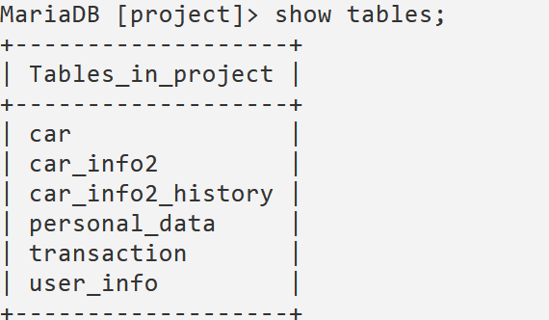

**2.CAR**

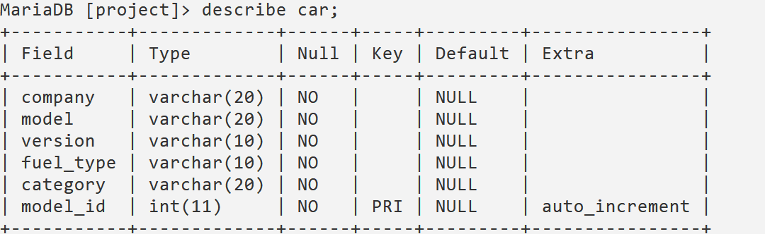

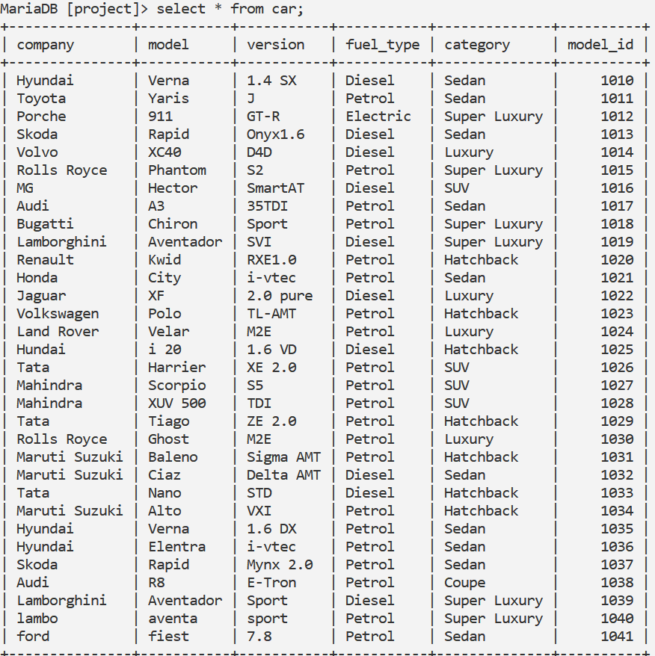

**3. CAR_INFO2**

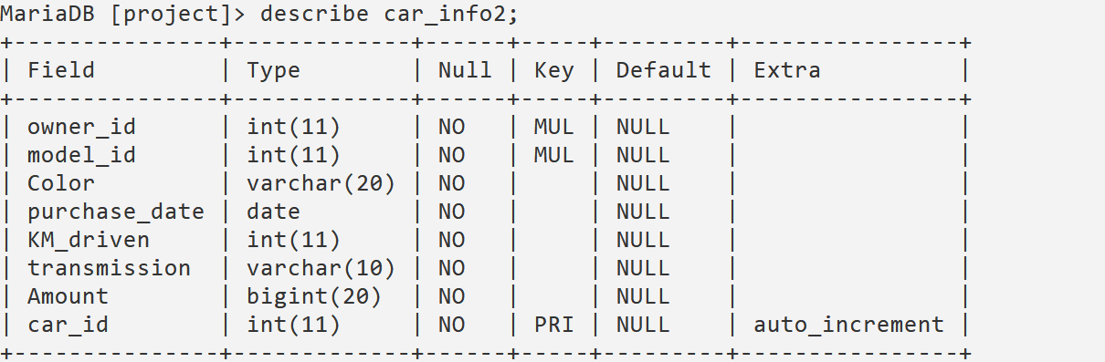

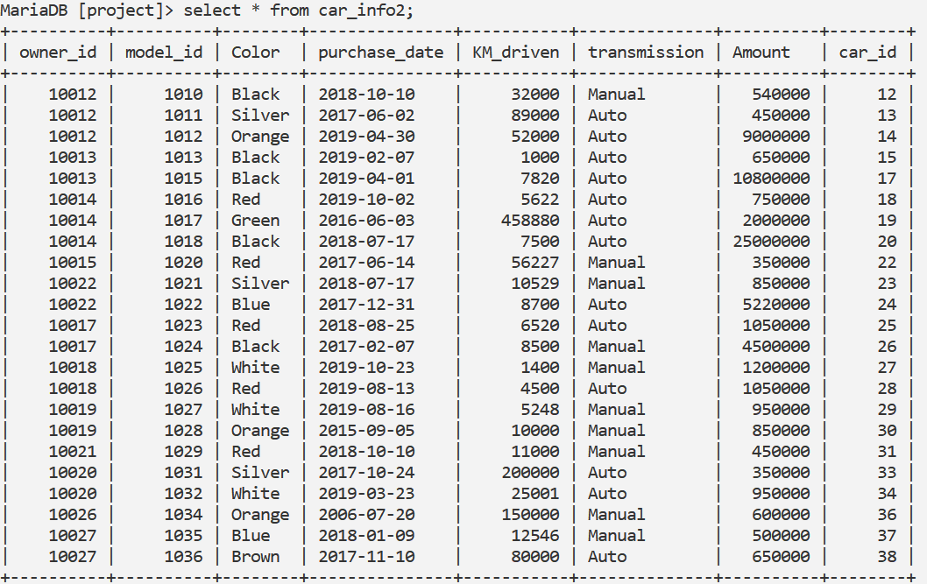

**4.CAR_INFO2_HISTORY**

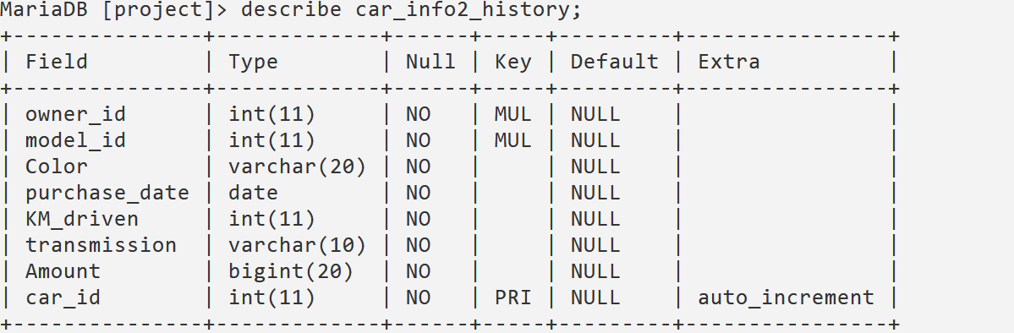

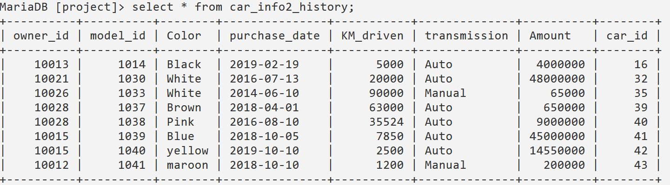

**5. PERSONAL_DATA**

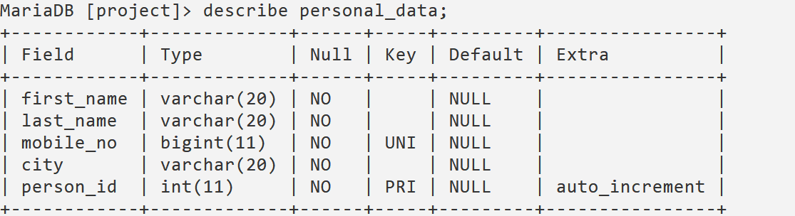

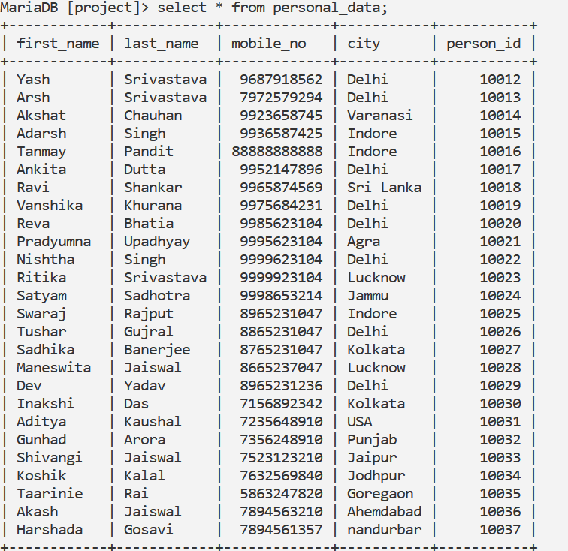

**6. TRANSACTION**

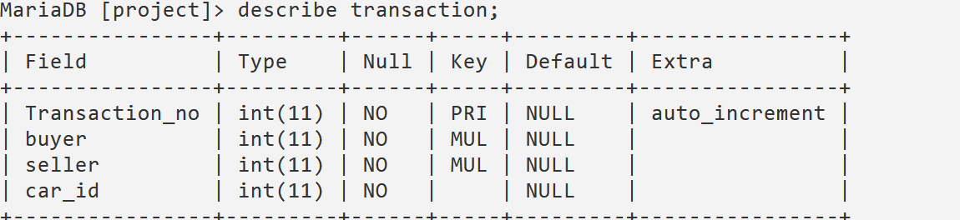

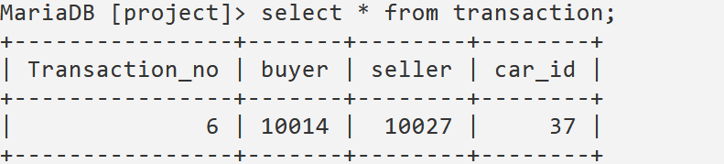

**7. USER_INFO**

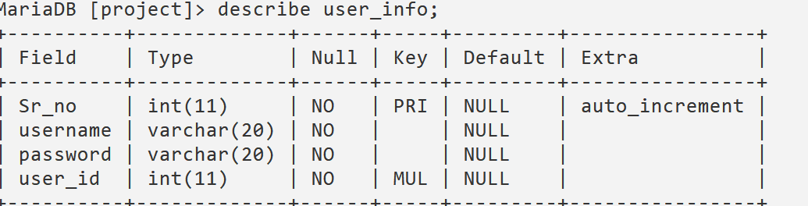

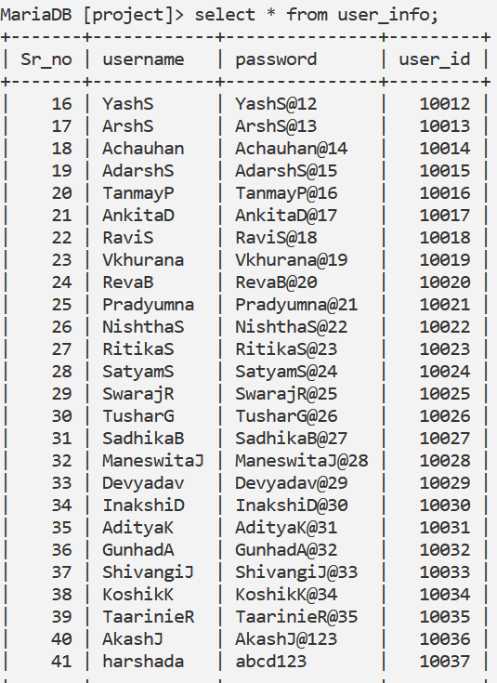

**Chapter 8**

**ER Diagram**

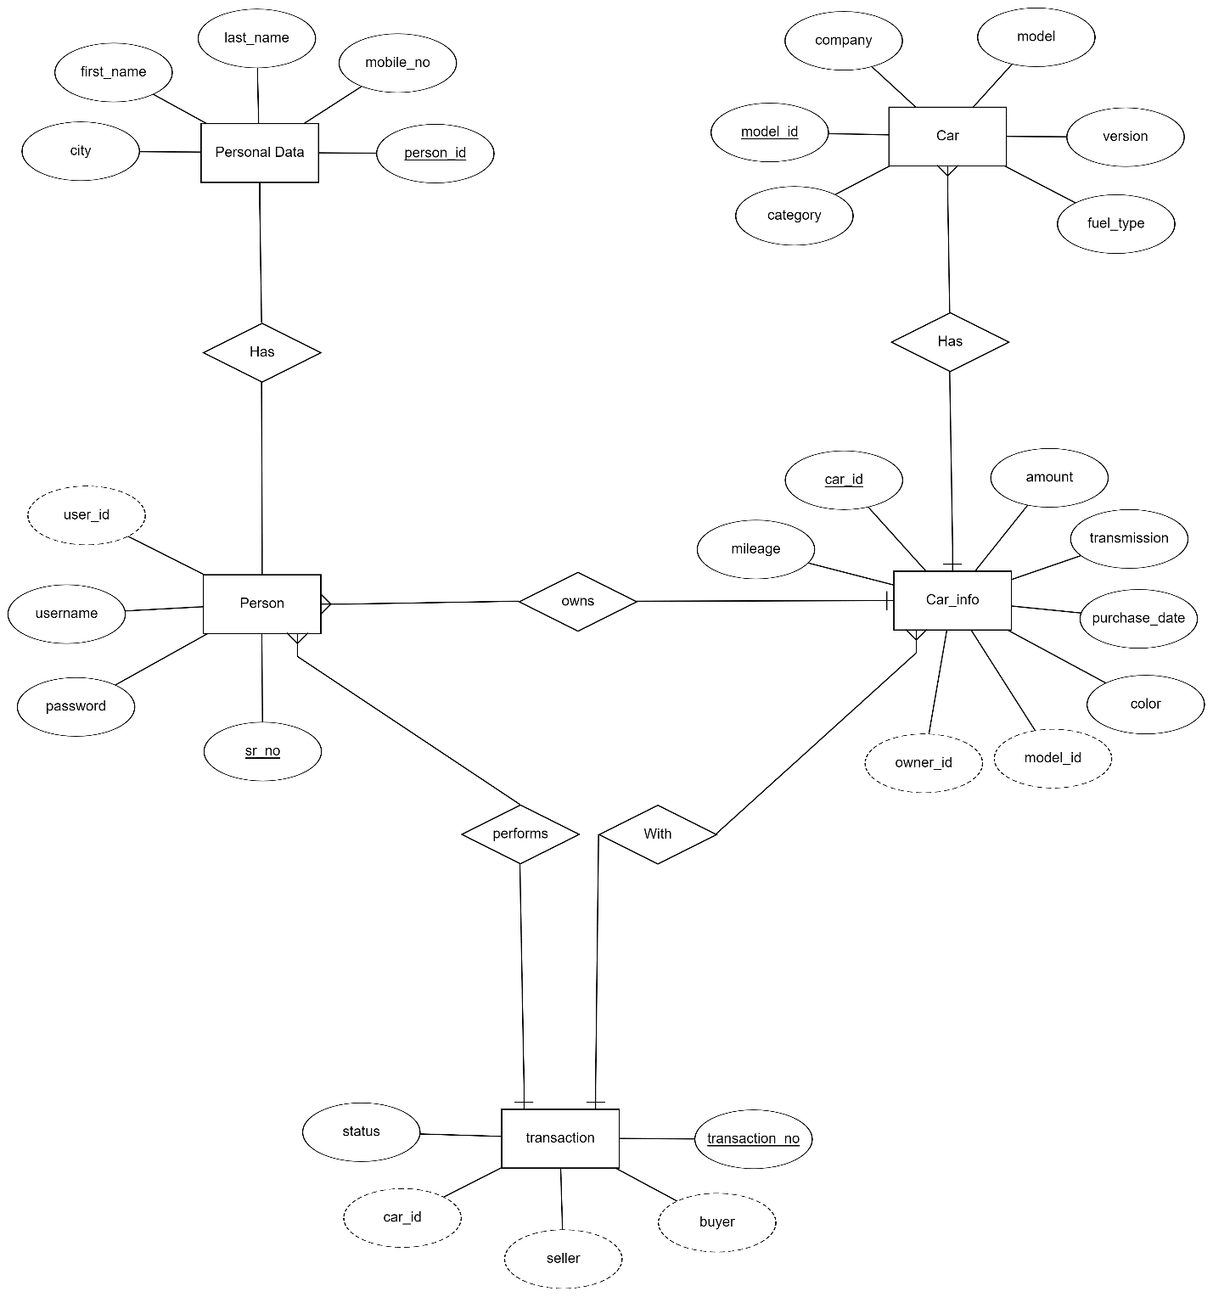

**Chapter 8**

**Output Screens**

**LOG-IN WINDOW**

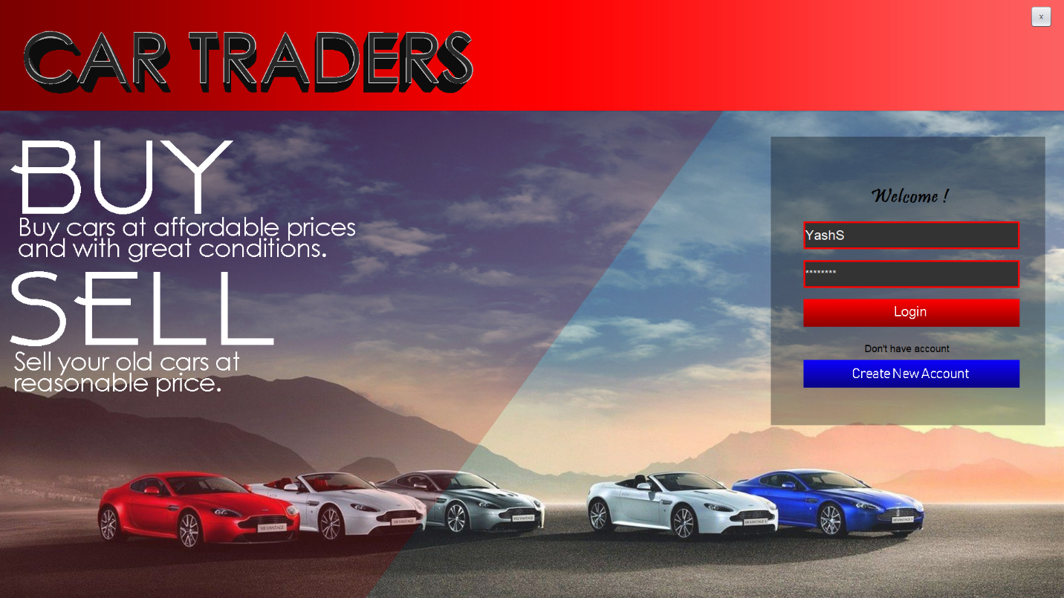

**MAIN WINDOW**

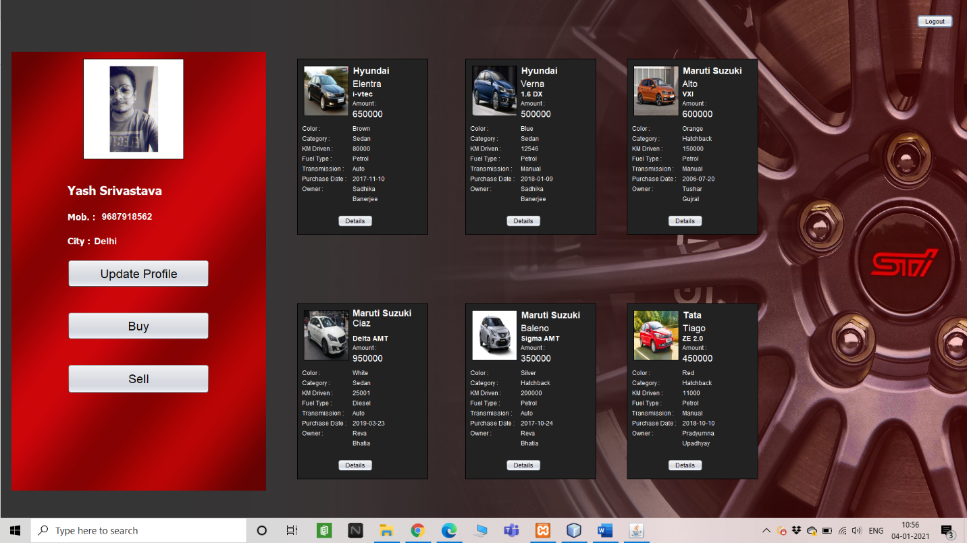

**UPDATE PROFILE WINDOW**

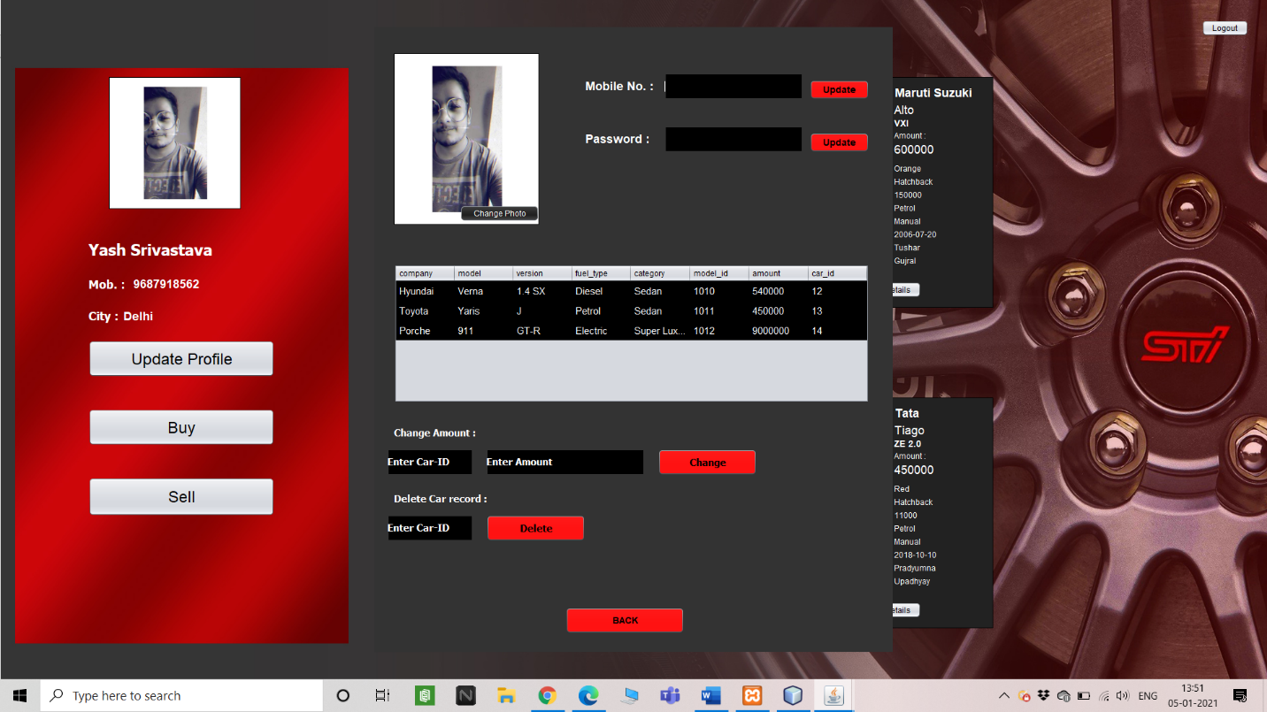

**BUY CAR WINDOW**

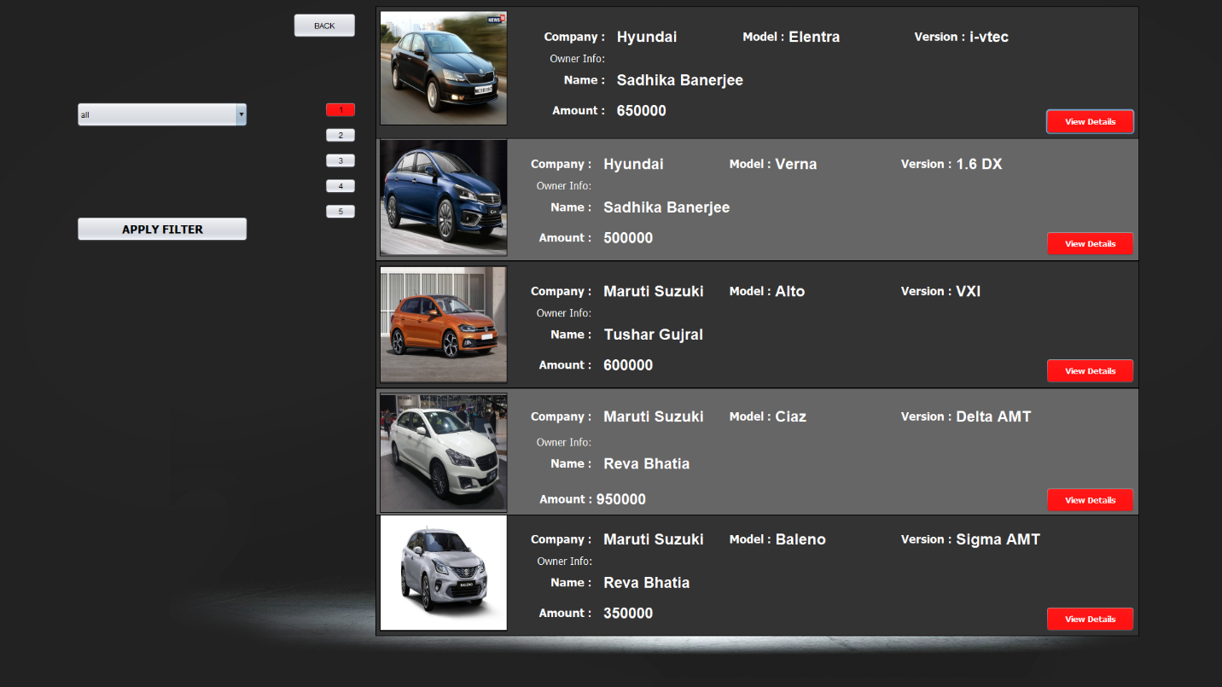

**SELL CAR WINDOW**

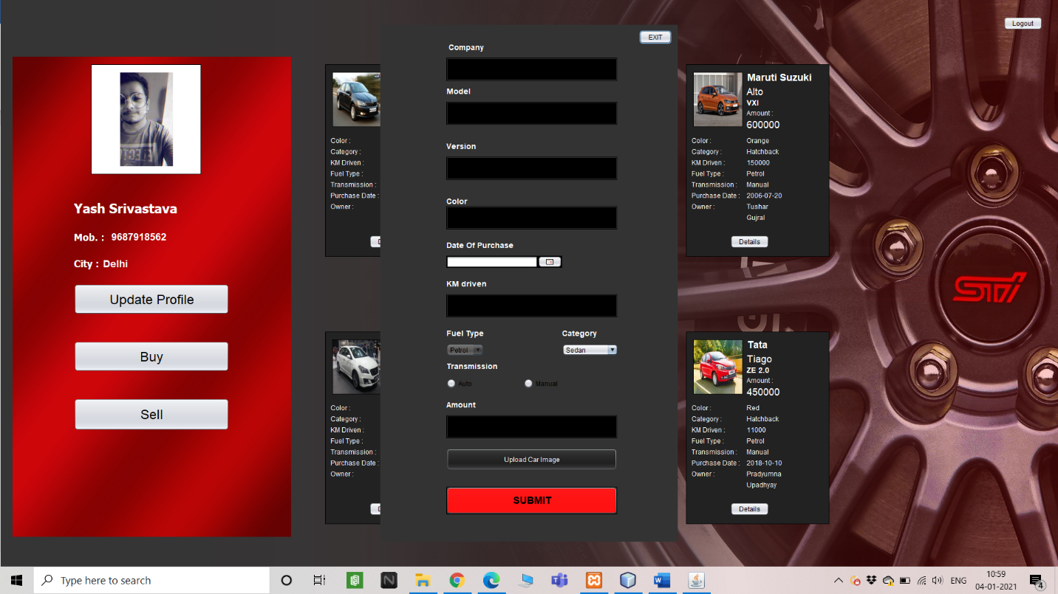

**VIEW CAR WINDOW**

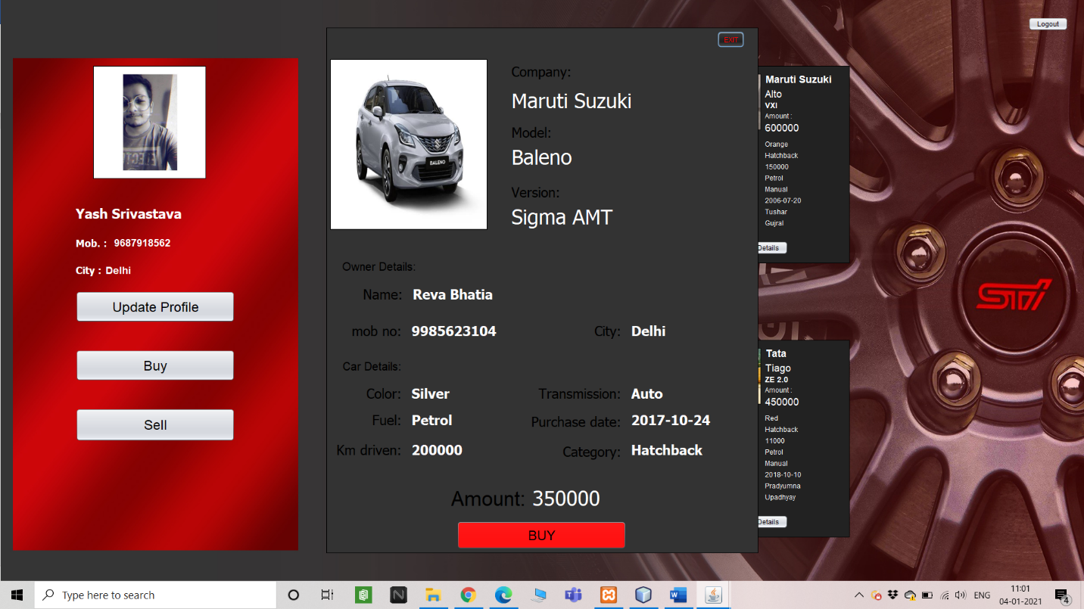

**Chapter 10**

**Sample Code**

private void jButton1ActionPerformed(java.awt.event.ActionEvent evt) {

String sql,temp_uname,temp_pass;

sql = "select username,password from user_info where username=? and password=?";

try{

conn = DbConnect.javaDb();

PreparedStatement pst1;

pst1 = conn.prepareStatement(sql);

temp_uname=jTextField1.getText();

temp_pass=new String(jPasswordField1.getPassword());

if(temp_uname.equals("")){

JOptionPane.showMessageDialog(null,"Enter username!!!!!");

}

if(temp_pass.equals("")){

JOptionPane.showMessageDialog(null,"Enter Password!!!!!");

}

pst1.setString(1,temp_uname);

pst1.setString(2,temp_pass);

//pst1.setString(2,pwd);

ResultSet rs;

rs = pst1.executeQuery();

if(rs.next()){

String sql2 ="select user_id from user_info where username=? and password = ?";

String sql3;

sql3="select user_id from user_data where username=? and password=?";

try{

PreparedStatement pst3;

pst3=conn.prepareStatement(sql2);

pst3.setString(1,temp_uname );

pst3.setString(2,temp_pass );

ResultSet rs3;

rs3=pst3.executeQuery();

if(rs3.next()){

Dbms2.g_user_id =rs3.getString("user_id");

}

}

catch(HeadlessException | SQLException e){

JOptionPane.showMessageDialog(null,e);

}

main_page w=new main_page();

w.setVisible(true);

this.setVisible(false);

}else{

JOptionPane.showMessageDialog(null,"Incorrect username or password","Error",JOptionPane.ERROR_MESSAGE);

jTextField1.setText(null);

jPasswordField1.setText(null);

}

}

catch(SQLException | HeadlessException ex){

JOptionPane.showMessageDialog(null,ex);

}

}

private void jPasswordField1KeyPressed(java.awt.event.KeyEvent evt) {

// TODO add your handling code here:

if(evt.getKeyCode()==KeyEvent.VK_ENTER){

String sql,temp_uname,temp_pass;

sql = "select username,password from user_info where username=? and password=?";

try{

conn = DbConnect.javaDb();

PreparedStatement pst1;

pst1 = conn.prepareStatement(sql);

temp_uname=jTextField1.getText();

temp_pass=new String(jPasswordField1.getPassword());

if(temp_uname.equals("")){

JOptionPane.showMessageDialog(null,"Enter username!!!!!");

}

if(temp_pass.equals("")){

JOptionPane.showMessageDialog(null,"Enter Password!!!!!");

}

pst1.setString(1,temp_uname);

pst1.setString(2,temp_pass);

//pst1.setString(2,pwd);

ResultSet rs;

rs = pst1.executeQuery();

if(rs.next()){

String sql2 ="select user_id from user_info where username=? and password = ?";

String sql3;

sql3="select user_id from user_data where username=? and password=?";

try{

PreparedStatement pst3;

pst3=conn.prepareStatement(sql2);

pst3.setString(1,temp_uname );

pst3.setString(2,temp_pass );

ResultSet rs3;

rs3=pst3.executeQuery();

if(rs3.next()){

Dbms2.g_user_id =rs3.getString("user_id");

}

}

catch(HeadlessException | SQLException e){

JOptionPane.showMessageDialog(null,e);

}

main_page w=new main_page();

w.setVisible(true);

this.setVisible(false);

}

}

catch(SQLException | HeadlessException ex){

JOptionPane.showMessageDialog(null,ex);

}

}

}

**Chapter 11**

**Conclusion**

In today’s ever expanding and demanding world there is always scope for improvement and workload with the help of software can be reduced to a great extent. In today’s world computers are used to increase the speed of the process. Hence this project aims on efficient and simple management of the feedback data receiving from the students of a department and storing and managing it in such a presentable manner in such a way to make the record easy to analyse by the admin and the staff database and update them. Hence this project provides faster and better approach to do so. Being cheap this is also easy to implement.

**Chapter 12**

**References**

1. Cay S. Horstman, Core Java , Prentice Hall Publishers
2. Silberschatz A., Korth H., Sudarshan S., "Database System Concepts", 4th Edition, McGraw Hill Publishers
3. Baron Schwartz, Peter Zaitsev & Vadim Tkacenko., High Performance MySql.,Published by O’Reilly
4. Microsoft Developers Network (**MSDN**) Library
5. Website:[**http://www.w3schools.com/**](http://www.w3schools.com/)
6. Website**:** [**http://www.geeksforgeeks.org/**](http://www.geeksforgeeks.org/)
7. Website:[**http://www.expertsexchange.net/**](http://www.expertsexchange.net/)